Housing Association Ltd

59 Cromwell Road Aberdeen, Scotland

ROBERT MCGILLIVRAY

01698 269 119

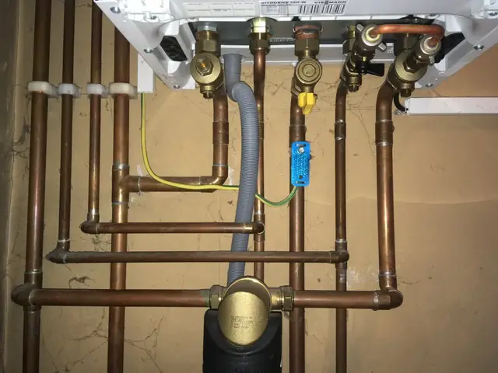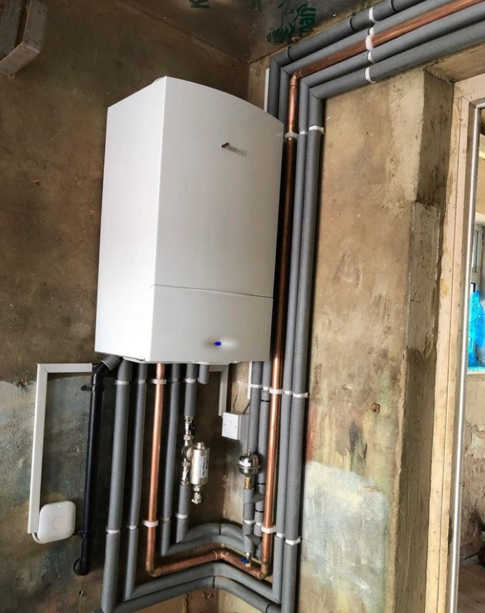

**Description Of Job**

Our team specializes in the installation of high-efficiency boilers, ensuring that they are integrated smoothly into your existing heating system. We prioritize safety and compliance with all industry regulations during the installation process.

We understand that each home is unique, which is why we conduct a thorough assessment before recommending the best boiler options for your needs. Our goal is to enhance your home's comfort while maximizing energy efficiency.

Once the installation begins, our skilled technicians will handle every aspect of the process, from removing old units to ensuring optimal placement of new boilers. We aim for minimal disruption to your daily routine.

Signature:

